Rebuilt Kadron Carburetors: An Installation, Tuning, and Troubleshooting Manual

This manual is a dual-purpose manual. It is to assist in installation of a carburetor kit, custom-built by the Kaddie Shack, and it is as a reference tool for those who may need help diagnosing or repairing their carburetors on their car. For those of you who have entrusted us to build you a well-matched set of our carbs: Thank you very much. You’ll soon see how much heart and soul we put into making our carbs the best in the business. This kit comes with air cleaners, greased between the cleaner elements and bases/lids, cork base gaskets, and pre-lubricated linkage and re-bushed Kaddie Shack throttle bodies that should last for life. It is highly recommended that you oil the gauze-type filters using an approved air cleaner element oil, such as the oil we carry in our store or the oil made by K&N. The idle and mixture screws are lubricated for easiest adjustment, too. The mixture screws are pre-set at 2 full turns, to make it as quick as possible to get them up and running. The accelerator pumps are preadjusted fairly close to where they should be for your particular application, the discharge nozzles are modified, checked for proper flow, and aimed to increase performance and decrease the likelihood of siphoning. The main and idle jets are to match the engine configuration specified in your order. In rare cases, final jetting adjustments may need to be done to match your particular engine perfectly. We’ll supply additional jets at no charge for fine-tuning in the event that you need them. However, it is very rare that jetting adjustments will be needed. We’d be happy to help you get your carbs dialed in. We have also inspected all parts of this system and replaced or repaired worn, missing, or defective pieces as necessary. We have poured a lot of blood, sweat, and tears into rebuilding these carburetors for you, and hope you enjoy them, even more than we’ve enjoyed building them for you (which is a bunch, by the way!). Horsepower gain per dollar spent, we think they’re the best performance enhancement you can get for your hard-earned money.

These carburetors are a very simple design, but like any performance modification, will take a little time and experimentation to dial in perfectly to match your particular engine and driving habits. With a little patience, and a little tuning prowess, you’ll have a fantastic upgrade over stock carburetion, and good looking carb set, too. This instruction manual is no doubt the beginning of a journey of performance improvements that you’ll enjoy doing to your VW, but it’s not the end-all, be-all of tuning. That would take a complete book! It will, however, get you through most of the basic stuff to have your carbs driving pretty nicely. Roll up your sleeves and let’s get going:
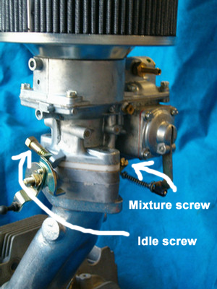
How to install and tune:

FUEL PRESSURE: It is super important that the fuel pressure is set to 1.75 PSI +/- 0.25 PSI for these carbs to work properly. Any higher than that and your needle and seats can seep and cause you all kinds of weird problems. Any lower, and you’ll run out of gas (usually on the freeway) when you’re really pushing it. If you’re using a stock fuel pump, you can lower the pressure if it’s too much by adding multiple gaskets under the fuel pump base, using a pressure regulator, or shaving a little metal at a time from the mechanical fuel pump drive rod. If you’re running a regulator, there is a separate section in the instructions to help you install it properly. Look at that first. Make sure your car is timed properly before converting to these carburetors, valves are adjusted, and the car is in good running order. When we install these carbs at the Kaddie Shack, we always install an adjustable fuel pressure regulator to assist in making our installations quicker and easier, and would recommend you do the same. We have kits that come with brackets, screws, and fittings, and even have a kit with a built-in gauge, should you choose to go that direction. Always install the regulator outside the engine bay and away from any source of heat or ignition. There are other ways of fixing fuel pressure issues, as discussed later in this manual. For maximum safety, we recommend removing your stock mechanical fuel pump, and installing an electric pump somewhere out of your engine bay area. We usually install the electric pump and regulator in the front of the vehicle, just under the fuel tank. If in a bus, over the transmission is probably most suitable. The installation of an electric pump will allow you to install a “Hard Line Kit” in your engine bay, eliminating all rubber fuel hoses.

Note: If your carburetor came with the recommended dual-cam, heim-equipped linkage, the installation procedure is slightly different, but the basic principles remain the same. Refer to the “Dual-Cam Linkage” section in the next section, as needed.

After removing your stock carburetor and intake manifold, you’re ready to begin.

Bolt the intake manifold assemblies up to your cylinder heads using supplied gaskets. The balance tubes, if they are to be utilized, will point toward the firewall of the car. Torque to 14 lb/ft. for dual port and 10 lb/ft. for single port. Install a balance tube (fuel lines with clamps provided) between the two intake manifolds facing the firewall. If installing on a late bus with a power brake booster circuit, you will add a tee in the balance tube as a source of vacuum for your booster.

Bolt up the linkage, hook up the fuel lines, and install return spring. There is no need for a synchrometer to set these carbs up properly. Follow this procedure for standard linkage. For dual-cam linkage, see the dual-cam linkage section below.

- First, back the idle speed screws out until there is a gap between them and the stoppers, and the throttle plates (butterflies) inside the carburetors are fully closed.
- Next, attach one side of the crossbar linkage to the throttle control arm. With standard linkage, just snap it to the ball. With the dual-cam linkage, attach it with the set screw and locking nut.
- Carefully guide the linkage on the other side to where it attaches to the other throttle control arm. Adjust the length of the crossbar until absolutely no movement occurs to either side when that arm is secured. Do this a couple of times until you know it’s perfect. Both butterflies should be perfectly closed when this is done perfectly, and both should open at EXACTLY the same time. The carbs are now synched. That wasn’t hard at all, huh?
- Verify that there is no binding through the full operation of the throttles and correct as necessary.
- Hook up the barrel nut to the throttle cable. Your cable may actually be too long, as some configurations require a shorter cable. We’d generally advise using a HEAVY DUTY cut-to-length type cable for this carb set, and we have those available through our store. In the meantime, you can use the barrel nut to secure the linkage to the cable itself until you get the correct cable. It’ll work fine.
- Push the accelerator pedal to the floor in the car all the way down, and verify that the carburetors are opening all the way, and returning back closed all the way. Verify that there is no binding whatsoever. Try it quickly, and try it slowly several times. Remember: A BINDING THROTTLE CABLE IS DANGEROUS. DO NOT PROCEED UNTIL SAFELY RESOLVED.
- If the carburetors do not open all the way, resolve that too, before attempting to drive the car. There are tips in the Troubleshooting section later in this manual.
- Turn one idle speed screw in now until it barely touches the stopper, then two more full turns to slightly open the throttle plates.

Once the carbs are installed, the linkage is set up properly, and everything is safe, it’s time to fire up the car. Grab a fire extinguisher and keep it handy. Get the car running and let it heat up to operating temperature, while checking for signs of fuel leaks, etc. The carburetors should be set up close enough for you to get them running right out of the box. If not, turn an idle screw until it will run on is own. Once it’s warm, you’re ready to start adjusting idle mixture. You’ll find the mixture screws in the throttle bodies preset to 2 turns. The one on the left side is easiest to get to with a very long and thin #1 or #2 standard (flat head) screwdriver, pointed down at an angle from behind the fan shroud. The one on the right side is tricky, too, and requires a stubby screwdriver oftentimes, unless your kit was ordered with a thumbwheel screw. Work on one carb at a time. Turn the mixture screw in and out, in and out, carefully listening for an RPM change with the engine running. The change is very slight when you get them close, so you’ll have to listen really carefully, The idea here is to get them adjusted right where they are running at the maximum RPM, and ¼ turn more. Turn the screws in until the RPM’s start going down. Then back them out ¼ turn at a time, listening for the RPM’s to go up. When the RPM’s fail to change because the idle is at its maximum, back the screw out 1/4 turn more. Do this procedure on each side twice, alternating back and forth, as adjustments to one side will effect the other.

Once the mixture is adjusted, you’ll want to adjust the idle speed. Turn the thumbscrew on the idles speed lever of one carburetor until the desired idle speed is achieved. Turn the other one so it barely contacts its stopper so they match. I personally like the idle to be a smidge higher than what the factory recommends. I like running it around 1100 RPM’s. maybe even slightly higher. This helps keep the car running on cold starts until it can heat up a bit. The trade-off here is that it idles higher than normal, but another added benefit is that the car will generally respond better to “dead spots” off idle, as often associated with use of a 009 distributor. The carbs you purchased from us are all modified for the “034”, or vacuum assisted distributor, which will operate smoother, and provide better mileage. After all this is done, turn off the car and check to make sure that both carbs are still fully open and against their stops with the gas pedal all the way down.

You’re done with the first part. Go for a drive.

The nice thing about Kadrons is that they are so easy to set up and adjust to make them run fairly decently. Tuning from here, however, make take a little more time. Small adjustments can be made to the accelerator pump by turning the 7mm nut on the rear side of the float bowl. Turning the nut in shoots a stream of fuel down the carb throat, helping to take flat spots out off idle. You want to run it in far enough to minimize response time between when you hit the pedal and when the car goes, but only that far, no more. Tightening the little nut shoots more fuel in the stream. Loosening it shoots less. The goal is to shoot just enough down the throat of the carburetor to eliminate any flat spots during acceleration, but no more. We pay careful attention to make sure they’re pre-adjusted as close as we can get them for your particular jetting and engine requirements. Usually, they’ll be right on. If not, they’ll be in the ballpark for sure. To tune it for the best mileage, performance, and to get the least amount of wear on your piston rings, you’ll want to adjust them to squirt the least amount of fuel with the best possible performance. The job of the pumps is to shoot a little fuel down into the combustion chambers as quickly as possible to match the air speed when the throttles are opened. Air will travel faster than fuel when the butterflies are opened, so the little extra burst of fuel is to eliminate any delayed imbalance in the mixture before the carburetor can begin metering the air/fuel properly.

Experiment also with changes in timing, from 28 to 32 degrees total advance to see where your car wants to be. Most run best between 30 and 32 degrees. We’ve seen some run best at up to 40 degrees and even higher if super low compression is used, and/or semi-hemi style heads. Each distributor has a different peak as to where the advance mechanism tops out. For instance, the “034” is at 3800 RPMs, the 009 is at around 3200. Every engine is different, too. Every car responds differently to different things. Take a little time making minor adjustments, one at a time, over a period of a few days, and you’ll have a really nice running machine when all is said and done. Monitor your spark plug color. Most every auto repair manual will have a chart on how to read spark plugs. If you don’t have a book, Google it. It’s important information to know. Check your tailpipe (for soot), and your oil and cylinder head temperature for additional signs of what your engine is telling you. Pay particular attention to sounds and noises. If you hear your engine popping, that’s generally a lean indication, and it must be fixed IMMEDIATELY, or you risk damaging your engine. This is especially relevant when you hear it past 2500 RPMs, or under load. Also, listen very carefully for that “Pinging”, or “Tapping” sound that indicates detonation is occurring. If you hear that sound, IMMEDIATELY pull over and fix it. Do not wait. Usually, you can fix a detonation problem, at least temporarily, by adjusting your timing down a few degrees.

I ALWAYS recommend gauges to monitor your temperatures and pressures. Your engine will tell you all sorts of information about how it is running by the temperatures and pressures that it is running with. I’d recommend cylinder head temperature as the #1 gauge you can install to tell you how your engine is doing. It’s the fastest indicator that a problem might be occurring. Yes. They’re expensive, but much cheaper than an engine. A close #2 would be oil temperature, followed by oil pressure. If you contact us, we’d be happy to share further advice about what which ones we prefer and why.

Also worth mentioning…

I ALWAYS recommend using Premium fuel, at least 91 octane or better, on any air-cooled engine, particularly if high performance modifications are made to it. Remember… these engines are of a 40+ year-old design, when the quality of gasoline was much better than it is today.

Dual-Cam Heim-Equipped Linkage:

In my opinion, this is the best linkage you can buy for a Kadron carb set-up, and it’s a little different than the standard linkage. The biggest difference is that the balls are replaced by screws with heim joints for more stability. Also, It is still a bellcrank, but it is a dual-cam operation, rather than a single rod. All tuning and installation principles remain the same. However, with this different design, the geometry changes a little. Here’s how to install it and set it up.

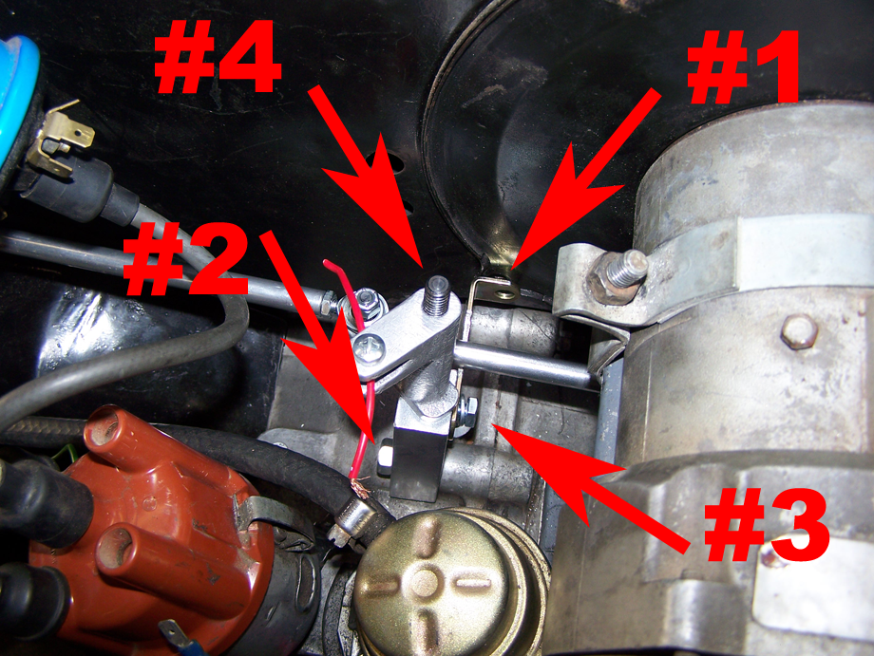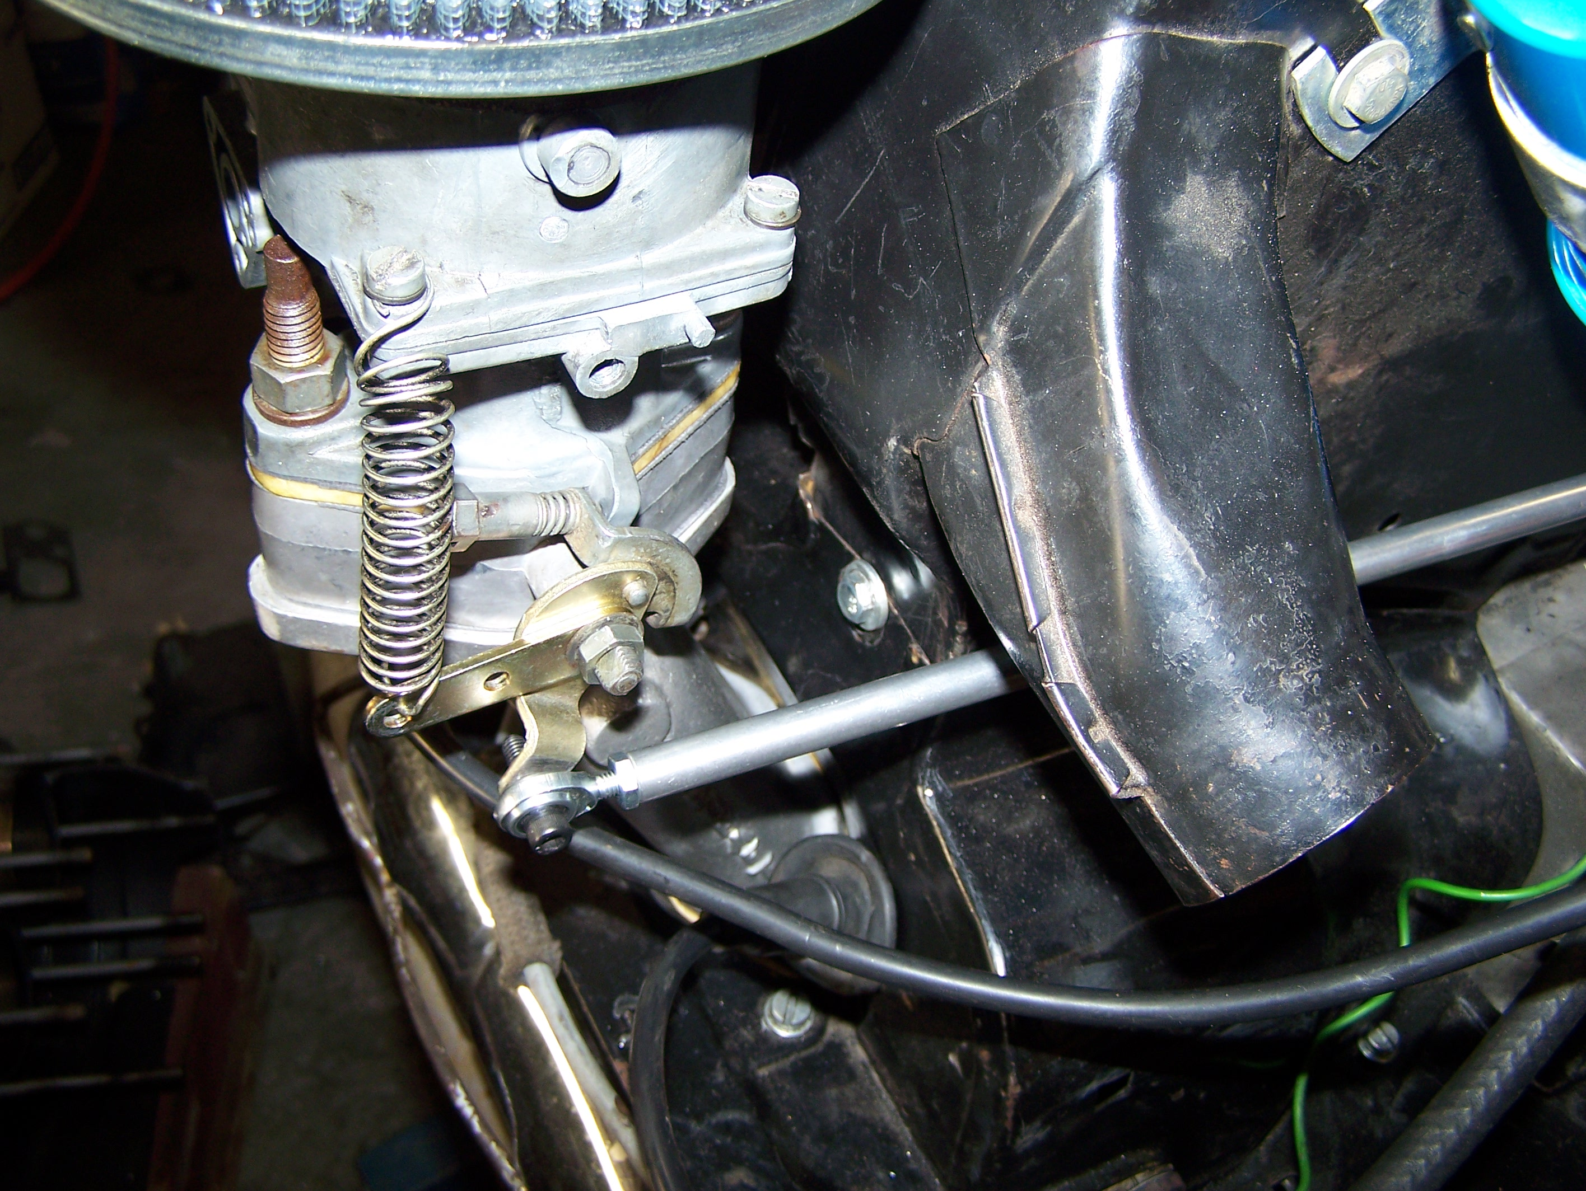

I have already made the linkage modifications to the throttle bodies of the carburetors to allow the upgraded stuff to bolt right up. Start with the center pull, though. Remove the lower left screw from your fan shroud that holds the alternator/generator tin. This will be replaced with the allen screw supplied with the kit, or use your original fan shroud screw. See Item #1. NOTE: It is common for the fan shroud retainer bracket to have to be notched to properly clear the linkage. We have done some experimentation here, and found that the linkage pivot arm seems to work quite well without a bracket on it. We have logged several thousand miles like this, and continue our testing. If you prefer to omit this bracket, we’d give you the green light to do so, knowing that you’ll need to check this periodically. If you have any feedback as the result of omitting this bracket during your installation, please let us know.
Remove the stud from the engine case directly to the left of the forward left generator/alternator pedestal bolt. This will be replaced by the supplied bolt. See Item #2.

When the bellcrank is installed, and the fan shroud bracket is attached, you will need to tighten the bracket that holds the two together. See Item #3. Finally, secure the top nut by lightly snugging the nut down, then backing it off so that you have zero vertical movement in the pivoting mechanism. See Item #4. Double-nut the connection to secure it by tightening the nuts together with two wrenches. Check to be sure there is free movement but no play in the bellcrank assembly.

Once this is complete, you can use the screws provided to attach the linkage arms to their respective carburetors. The longer arm goes to the right carburetor, the short to the left. The length of the linkage is adjusted by loosening the side nuts and turning the middle tube, just like a tie rod. There is no need to disconnect them. Just remember, one nut is left-handed thread on each tube!

Other than that, the principle is the same. For informational purposes, the spring cams are installed on both carbs to allow springs on both sides. We usually install them in the innermost hole, but one or both can be moved to the outer hole for additional spring tension, such as in a bus where more leverage is needed. Also, the throttle arm on the right side has been reversed from its stock orientation. Additionally, the balls have been punched out and the holes enlarged to 3/16” accommodate the supplied heim joint screws.

FUEL PRESSURE REGULATORS:

If you chose to use a fuel pressure regulator, either ours, or one from another supplier, installation of this component has some things that you need to be aware of. First of all, make sure there is at least 6” of fuel line between the pump and the regulator. We always recommend installing the regulator outside of the engine bay, and away from any source of heat or ignition. Ideally, this is best accomplished by installing an electric pump and the regulator in the front of the car, under the fuel tank. If you choose to run without with the stock fuel pump, you’ll need to be a little more creative with the regulator mounting location. Also, regulators are not reversible. Make sure you look to be sure that “IN” is in, and “OUT” is out. Make sure the regulator is mounted below the top of the float bowl on the carbs if at all possible. Another thing: I’ve noticed by hooking up gauges and taking readings at the fuel system that the numbers on the regulators do not always reflect pressure. “3” on one regulator may mean 1.5 psi, whereas “1” on another regulator may be the same. Testing the ones we use here, we’ve found that “2” is almost always “spot on” to where you need to be. Set it at “2” and forget it, if using ours. If you’ve purchased one elsewhere, and you don’t have a fuel pressure gauge, here’s how I’d tackle it: I’d start by setting it to “3”. If it slowly starves for fuel after running awhile (even idling), or starts sputtering or pops when accelerating up a hill in high gear, adjust it a click or two higher. If it sputters, smokes, smells like fuel, burns your eyes, leaks out of the tailpipe, or otherwise floods at idle, adjust the pressure down. It may take a little working at to get it to where it’s just right, especially without a pressure gauge. Stick with it. That’s part of the fun. Better yet: borrow or buy a pressure gauge.

TROUBLESHOOTING PROBLEMS:

Before you assume you have carb problems, be sure to make sure the basics are all in line: Timing, valve adjustments, plug gap, ignition dwell (yes… buy a dwell meter or go with electronic ignition!), plug wires, and all the basic stuff needs to be checked to ensure it’s in proper working order. Once all of these things are checked, get to troubleshooting the carburetion system.

By far, the #1 problem that I run into is excessive fuel pressure. Don’t just glaze over this and hope it’s something else. Before you even do anything else, if your carbs aren’t running right, check fuel pressure. As stated before, 2 PSI is MAX, and 1.5 is even better. Shim your fuel pump with extra gaskets, grind a little off of your fuel pump drive rod, add a fuel pressure regulator, whatever it takes to get the pressure reasonable. Don’t assume it’s not your problem, because I usually find it is. One telltale sign of excessive fuel pressure is a spitting, bubbling, leaking annular discharge booster (. It’s the little circular thing in the throat of the carburetor where the fuel comes out.) or accelerator pump discharge nozzle at idle If you see fuel coming out of it at idle, fuel pressure is likely excessive.

Closely related, is weeping or dripping of the accelerator pump discharge nozzle. This, like other Kadron problems, can be caused by #1, but after that is resolved, check the adjustment. When we set these carbs up, we do our best to make sure the accelerator pumps are adjusted properly. We also modify the design of the discharge nozzles so as to minimize the vacuum that is created in the venturi, which might cause the nozzles to siphon gasoline from the float bowl. Each engine is different, however. If the car seems lumpy or soggy, and gets poor mileage, and everything else is OK, you could have one or both sides dripping fuel from the discharge nozzles. These are the little brass things inside the carb throats that you can see with the air cleaners off. See the following photo. If they are dripping at all down the throats at idle, carefully adjust the little 7mm nuts on the accelerator pump drive rods until the dripping stops. A photo is also shown of this nut. It is the black plastic one in the second photo. They can also be made out of brass or steel, and may have a smaller secondary nut to secure them. In rare cases, you might have to add more washers (or a nut or other shim) than I have already added to get it to stop dripping. This is not common.

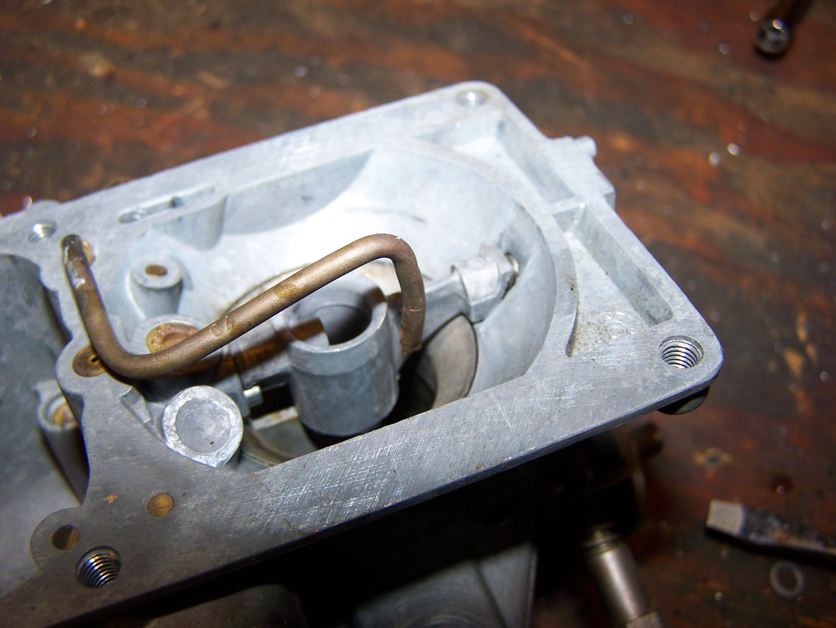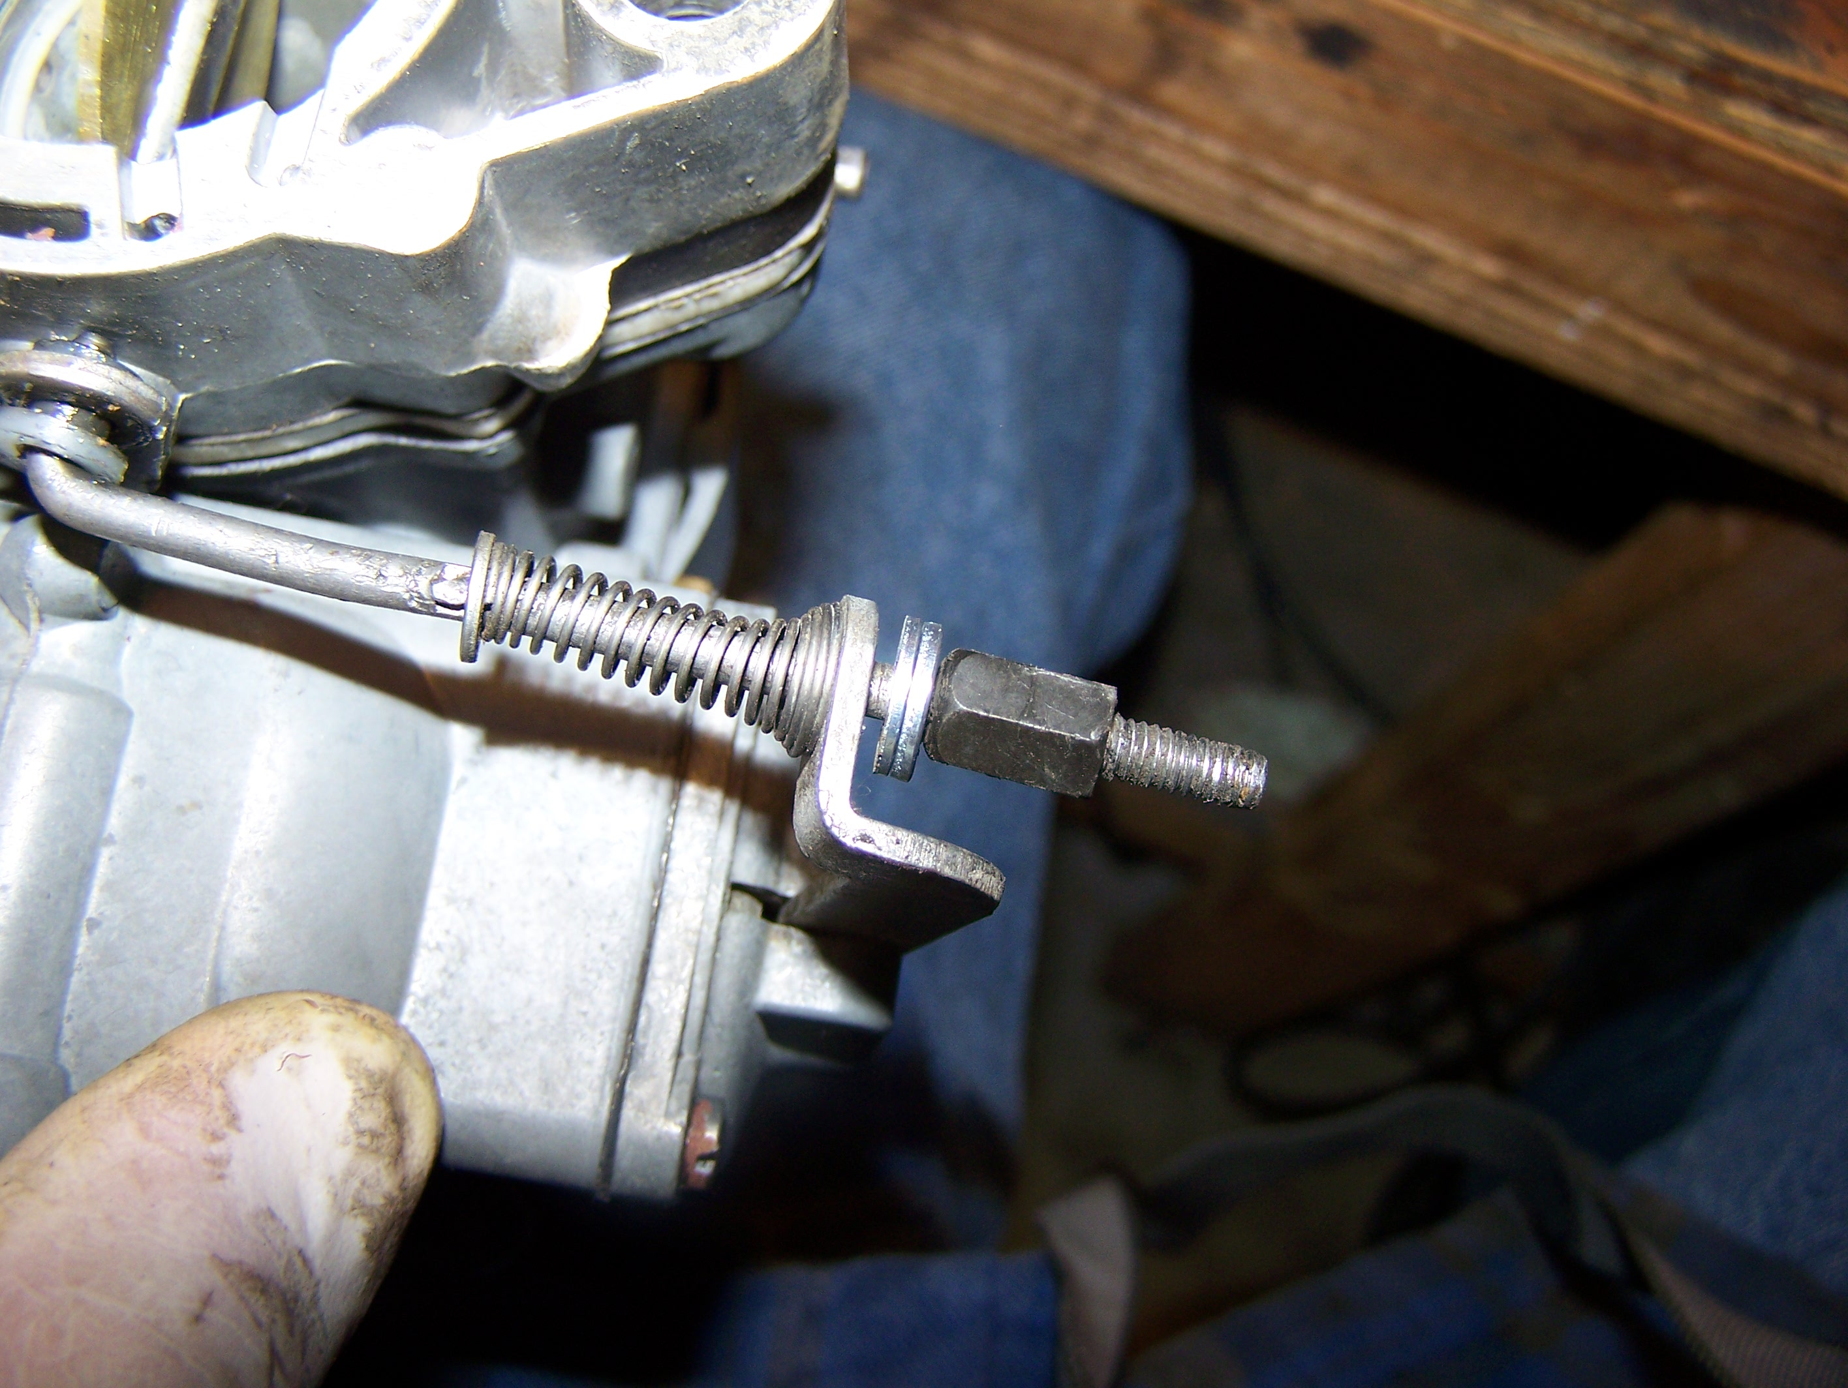

If fuel pressure is adjusted too low, your car will run out of gas while driving. This will happen when moving at high speeds for an extended period of time, and while under a load, such as pulling a hill with the throttle wide open. If this happens, don’t panic. Adjust the regulator you (hopefully) purchased up a notch and continue on.

If fuel continues to flow after your engine is shut off, filling up your venturis, or leaking out your throttle bodies: This is another fuel-related issue that seems to be prevalent: Keep your fuel lines (and tank) mounted below the top of your carburetor float bowls if at all possible. If they are too high, gravity can cause them to leak into the carbs and wreak havoc on your system. I know, I know. You have a really cool fuel filter that you want displayed over your fan shroud. Move it! This also applies to fuel tanks mounted over the carburetors. If you have a fuel tank in the rear package tray area, it can cause problems in the fuel system due to gravity. Even with the car shut off completely, I’ve seen gravity fill an entire venturi up with gasoline after a engine has been shut off. This can be dangerous. Installation of a regulator can also stop this from occurring if the tank is in the package tray area, such as in a baja bug or a sand rail.

Hard to start after the engine is warm: This can be caused by a few things. Improper jetting, or a fuel system that is allowing fuel into the intake system after the car is shut down. The items mentioned in the paragraph before this can cause this effect. Boiling fuel due to fuel lines routed too close to the exhaust or some other heat source can cause this. I’ve seen this, too. Sometimes this will lead to vapor-lock when driving, as well. An improperly vented fuel tank can cause pressure to build up in the tank, thus causing fuel lines to be pressurized after the car is shut off, especially if parked in the sun. This will overcome the needle and seats in the carburetors, and flood the engine with gasoline, causing hard starts. Make sure you don’t hear a “FFFSSSTT” sound when you remove your gas cap on a hot day. If you do, vent the fuel tank to relieve pressure.

One carburetor will not adjust to idle mixture screw adjustments: There can be several causes of this. One cause is an intake system air leak, either from the screw holding the butterfly in the thottle body, (hopefully not a Kaddie Shack throttle body!), between the cylinder head and the intake manifold, between the carburetor base and the intake manifold, in the vacuum routing, from a cracked manifold, etc. Spray a non-flammable aerosol toward each joint, and listen for a change in idle speed. I’ve found that sometimes holding your hand over the intake of the carburetor helps locate this, too. I wouldn’t officially advise it, as there are risks of injury involved here, but I’ve actually covered the entire intake area of a carburetor and found that it makes the car speed up, rather than try to stall. When applying the same procedure on the opposing carburetor, the engine slows down. This is a tell-tale sign of an intake leak. Again… I wouldn’t advise doing it this way, but similar and safer methods could be used to choke off incoming air. An improperly closing idle mixture screw can also cause this, but we’ve tested yours if you purchased the carbs from us.

The dreaded “Flat Spot”: Yes. There is a possibility that you will have a set of carbs that appears to fall on its face as soon as you hit the gas, stumbling, then all of a sudden kicks in and runs fine. This may or may not be carburetors. Sometimes, it’s usually a matter of getting spark at the right time to ignite the compressed fuel and air mixture to match engine speed, compression ratio, and combustion chamber design. This usually happens with a “009” centrifugal advance distributor, and happens most with the later non-German made models. That flat spot will go away if you use a SVDA (Single Vacuum Dual Advance) distributor. The time-tested and proven one is the “034”. Yes, we carry a number of those, too. This advances the timing immediately off idle, giving a quick jolt to the system to get you over that hump. Additionally, it advances your timing at sustained speed when your pedal is only partially applied, leaving you with less fuel consumption (better mileage) a cooler running engine, and better performance. Who can argue that? It’s something to think about. Oftentimes the flat spot can be minimized or removed by adjustments to the fuel pump drive rod mentioned earlier, in combination with adjustments in timing and jetting Too much fuel squirting into the intake system can cause temporary flooding, and too little can cause a temporary lean condition. Not all engines are the same. Every one is a little different. Try different timing See what your car responds to best.

Throttles don’t open all the way when the accelerator pedal is depressed: There are all sorts of causes for this. We see lots of them during our installations. A misrouted throttle cable can cause this. Look behind the fan shroud at the flexible guide tube from the chassis to the rigid tube at the engine tin. Another very common cause is binding of the crimped portion of the cable at the guide tube where it enters the chassis behind the accelerator pedal. It’s common to have it misaligned with the tube, the wrong cable installed, the cable installed improperly at the pedal assembly, the cable improperly lubed, the guide tube bent, or the cable binding on carpeting installed in this area. If all else fails, one can remove the throttle pedal and grind some material off of the bottom of the return stopper than usually contacts the floor. This will cause your pedal to travel further back, thus giving more travel to the cable. If you have a roller pedal, you can also drill the hole higher and attach the cable end up more to allow more cable travel.

Popping during deceleration: There can be many causes for this, so tackle it step-by step. The first thing you need to check for is an intake system leak. Spray carb cleaner or something similar around all potentially leaking areas, as outlined before to locate this. Also, double check for exhaust leaks, as this can cause a popping under certain circumstances. Next, you can adjust your accelerator pump flow by screwing the little nuts pictured previously in the photo on the right. Turning the nuts clockwise increases flow, while turning them counter-clockwise decreases it. Next, the idle jets can get clogged with debris from your fuel system.. The little holes are pretty small, and can get clogged with a spec of dust or other debris that may have found its way past your fuel filter. If these don’t work, a jetting change may be in order.

MAINTENANCE:

Your Kadrons should last a good, long time if maintained properly. Maintenance should be performed with every oil change, or if you go in the dirt like I do: Every time after you go out. Clean the linkage and lube it with a lightweight penetrating oil such as Penn fishing reel oil, or Liquid Wrench, both at the throttle bodies and at the linkage pivot points if you have Scat linkage. Spray the exposed metal pieces such as screws, drive rods, and linkage cams with a corrosion inhibitor, such as gun oil. Each ball and socket joint should me greased with a general chassis grease. I recommend popping the balls out of the sockets, cleaning the sockets with brake cleaner, and re-applying grease on a Q-Tip. Clean the balls while the sockets are off. Dab a little grease on the accelerator pump lever where it attaches to the drive rod, too. If you live in a salty environment, clean and oil your carbs with a protective oil regularly to prevent them from corrosion. Be sure to spray all linkage arms, as well as the throttle shafts. I’d recommend spraying the shafts (both sides) with the engine running to ensure they both get lubricant inside of them.

Most importantly, clean and oil your air cleaners regularly with approved air cleaner oil. We sell top-notch stuff, or you can buy K&N air cleaner oil and degreasers at your local auto parts store. Dirty or dry air cleaners do very little to protect your engine. Our carb kits come with gauze type elements, and they need oil to function properly!
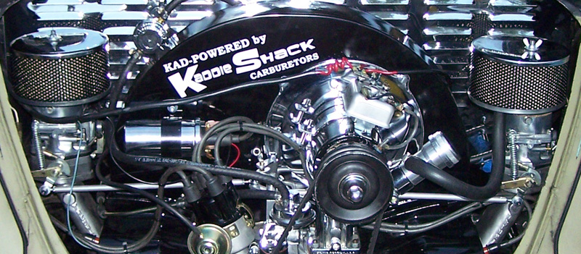

Legal Note: I include these instructions with the best of intentions, but if it doesn’t run right, you catch your car on fire, your engine blows, or your hair gets caught in the fan belt…. WE ARE NOT RESPONSIBLE. We built you a set of top-notch racing carbs. These carburetors were sold to you under the understanding that you are fairly mechanically inclined, have some VW engine know-how, or are going to be installed by a professional mechanic. They will need to be fine-tuned to your engine for best performance and reliability, which may include jetting changes. We will provide jets free of charge on an exchange basis within 90 days, should you need a change from what we originally sent, unless your application has changed. THIS IS VERY RARE. Usually, when a problem occurs, after troubleshooting extensively with customers, we find that jetting is the first thing the customer believes to be the problem, but in all actuality, is not the case. Changing jets can mask the original problem, but complicate tuning and create other problems that are more difficult to repair. Fine-tuning with a “wideband” is recommended for maximum performance. I will need your wideband readings when selecting replacement jets. These racing carburetors are not legal to run on the street, but are terrific to run off-road or on a drag strip. They are to be installed in such a vehicle, and used likewise.

Revised regularly, and most recently on 11/4/2012.

